**///** /Thematic workshop 1 OSLO Air & Water/

**////////////////////////////////////////////////////////////////////////////////////////////////////////**

**Datum**: 09/02/20219: 13:00 – 15:30 CET

**Locatie**: Online - Microsoft Teams Meeting

|  |  |
| --- | --- |
| **[Belgian national & regional governments](https://www.google.be/maps/place/Boudewijngebouw/@50.8567731,4.3526172,17z/data=!3m1!4b1!4m5!3m4!1s0x47c3c38369503633:0xe176454918e1b130!8m2!3d50.8567731!4d4.3548059?hl=nl)** | [Michiel De Keyzer - Digitaal Vlaanderen](https://www.google.be/maps/place/Boudewijngebouw/@50.8567731,4.3526172,17z/data=!3m1!4b1!4m5!3m4!1s0x47c3c38369503633:0xe176454918e1b130!8m2!3d50.8567731!4d4.3548059?hl=nl)  [Kevin Haleydt - Digitaal Vlaanderen Frederik Van den Houdt, Digitaal Vlaanderen Philippe Michiels - Digitaal Vlaanderen Frank Lavens, Vlaamse Milieumaatschappij Geert Thijs, OSLO-team, Digitaal Vlaanderen Katleen Miserez, Vlaamse Milieumaatschappij Greet Devriese, Vlaamse Milieumaatschappij](https://www.google.be/maps/place/Boudewijngebouw/@50.8567731,4.3526172,17z/data=!3m1!4b1!4m5!3m4!1s0x47c3c38369503633:0xe176454918e1b130!8m2!3d50.8567731!4d4.3548059?hl=nl)  [Annelies De Craene, Digitaal Vlaanderen](https://www.google.be/maps/place/Boudewijngebouw/@50.8567731,4.3526172,17z/data=!3m1!4b1!4m5!3m4!1s0x47c3c38369503633:0xe176454918e1b130!8m2!3d50.8567731!4d4.3548059?hl=nl)  [Jurgen Meirlaen, Vlaamse Milieumaatschappij](https://www.google.be/maps/place/Boudewijngebouw/@50.8567731,4.3526172,17z/data=!3m1!4b1!4m5!3m4!1s0x47c3c38369503633:0xe176454918e1b130!8m2!3d50.8567731!4d4.3548059?hl=nl)  [Geert Van Haute, Departement Omgeving](https://www.google.be/maps/place/Boudewijngebouw/@50.8567731,4.3526172,17z/data=!3m1!4b1!4m5!3m4!1s0x47c3c38369503633:0xe176454918e1b130!8m2!3d50.8567731!4d4.3548059?hl=nl)  [Tom Van Herck](https://www.google.be/maps/place/Boudewijngebouw/@50.8567731,4.3526172,17z/data=!3m1!4b1!4m5!3m4!1s0x47c3c38369503633:0xe176454918e1b130!8m2!3d50.8567731!4d4.3548059?hl=nl) |
| **[National or regional governments](https://www.google.be/maps/place/Boudewijngebouw/@50.8567731,4.3526172,17z/data=!3m1!4b1!4m5!3m4!1s0x47c3c38369503633:0xe176454918e1b130!8m2!3d50.8567731!4d4.3548059?hl=nl)** | [Jesper Zedlitz, Ministry of Digitization, Schleswig-Holstein, Germany](https://www.google.be/maps/place/Boudewijngebouw/@50.8567731,4.3526172,17z/data=!3m1!4b1!4m5!3m4!1s0x47c3c38369503633:0xe176454918e1b130!8m2!3d50.8567731!4d4.3548059?hl=nl) |
| **[Local administration Europe](https://www.google.be/maps/place/Boudewijngebouw/@50.8567731,4.3526172,17z/data=!3m1!4b1!4m5!3m4!1s0x47c3c38369503633:0xe176454918e1b130!8m2!3d50.8567731!4d4.3548059?hl=nl)** | [Benjamin Gärtner, City of Heidelberg, Germany](https://www.google.be/maps/place/Boudewijngebouw/@50.8567731,4.3526172,17z/data=!3m1!4b1!4m5!3m4!1s0x47c3c38369503633:0xe176454918e1b130!8m2!3d50.8567731!4d4.3548059?hl=nl) |
| **[Research institutions](https://www.google.be/maps/place/Boudewijngebouw/@50.8567731,4.3526172,17z/data=!3m1!4b1!4m5!3m4!1s0x47c3c38369503633:0xe176454918e1b130!8m2!3d50.8567731!4d4.3548059?hl=nl)** | [Pieter Colpaert Harm Delva, Ghent University - imec, Belgium](https://www.google.be/maps/place/Boudewijngebouw/@50.8567731,4.3526172,17z/data=!3m1!4b1!4m5!3m4!1s0x47c3c38369503633:0xe176454918e1b130!8m2!3d50.8567731!4d4.3548059?hl=nl)  [Frank Sleeuwaert, VITO, Belgium](https://www.google.be/maps/place/Boudewijngebouw/@50.8567731,4.3526172,17z/data=!3m1!4b1!4m5!3m4!1s0x47c3c38369503633:0xe176454918e1b130!8m2!3d50.8567731!4d4.3548059?hl=nl)  [Fernando López, FIWARE Foundation, Germany](https://www.google.be/maps/place/Boudewijngebouw/@50.8567731,4.3526172,17z/data=!3m1!4b1!4m5!3m4!1s0x47c3c38369503633:0xe176454918e1b130!8m2!3d50.8567731!4d4.3548059?hl=nl) |
| **[Other](https://www.google.be/maps/place/Boudewijngebouw/@50.8567731,4.3526172,17z/data=!3m1!4b1!4m5!3m4!1s0x47c3c38369503633:0xe176454918e1b130!8m2!3d50.8567731!4d4.3548059?hl=nl)** | [Stijn Van Hoey, Fluves, Belgium](https://www.google.be/maps/place/Boudewijngebouw/@50.8567731,4.3526172,17z/data=!3m1!4b1!4m5!3m4!1s0x47c3c38369503633:0xe176454918e1b130!8m2!3d50.8567731!4d4.3548059?hl=nl)  [Niels Melotte, De Vlaamse Waterweg, Belgium](https://www.google.be/maps/place/Boudewijngebouw/@50.8567731,4.3526172,17z/data=!3m1!4b1!4m5!3m4!1s0x47c3c38369503633:0xe176454918e1b130!8m2!3d50.8567731!4d4.3548059?hl=nl)  [Elien Dewitte - VLIZ - Beligum Laurian Van Maldeghem, Flanders Marine Institute (VLIZ),](https://www.google.be/maps/place/Boudewijngebouw/@50.8567731,4.3526172,17z/data=!3m1!4b1!4m5!3m4!1s0x47c3c38369503633:0xe176454918e1b130!8m2!3d50.8567731!4d4.3548059?hl=nl)  [Belgium](https://www.google.be/maps/place/Boudewijngebouw/@50.8567731,4.3526172,17z/data=!3m1!4b1!4m5!3m4!1s0x47c3c38369503633:0xe176454918e1b130!8m2!3d50.8567731!4d4.3548059?hl=nl)  [Peter Braem, Proximus, Belgium](https://www.google.be/maps/place/Boudewijngebouw/@50.8567731,4.3526172,17z/data=!3m1!4b1!4m5!3m4!1s0x47c3c38369503633:0xe176454918e1b130!8m2!3d50.8567731!4d4.3548059?hl=nl)  [Gert De Tant - ODALA](https://www.google.be/maps/place/Boudewijngebouw/@50.8567731,4.3526172,17z/data=!3m1!4b1!4m5!3m4!1s0x47c3c38369503633:0xe176454918e1b130!8m2!3d50.8567731!4d4.3548059?hl=nl)  [Laurens Horvath - ALTIS](https://www.google.be/maps/place/Boudewijngebouw/@50.8567731,4.3526172,17z/data=!3m1!4b1!4m5!3m4!1s0x47c3c38369503633:0xe176454918e1b130!8m2!3d50.8567731!4d4.3548059?hl=nl) |

**////////////////////////////////////////////////////////////////////////////////////////////////////////**

|  |  |
| --- | --- |
| **Part 1** | Welcome, purpose, agenda, practicalities + klaxoon exercise “who’s in the room?” |
| **Part 2** | Scope of the OSLO project and results of the previous workshop + klaxoon exercise “Data classes / attributes” |
| **Part 3** | Reviewing the preliminary use case + brainstorm |
| **Part 4** | Initial thoughts of comparison + brainstorm |
| **Part 5** | The object diagram + klaxoon exercise “open questions” |
| **Part 6** | Next steps |

# Agenda of the workshop

1. **Welcome, purpose, agenda and practicalities**

In part 1 of the workshop, a general introduction was made & we got a better understanding of the participants present at the workshop via Klaxoon.

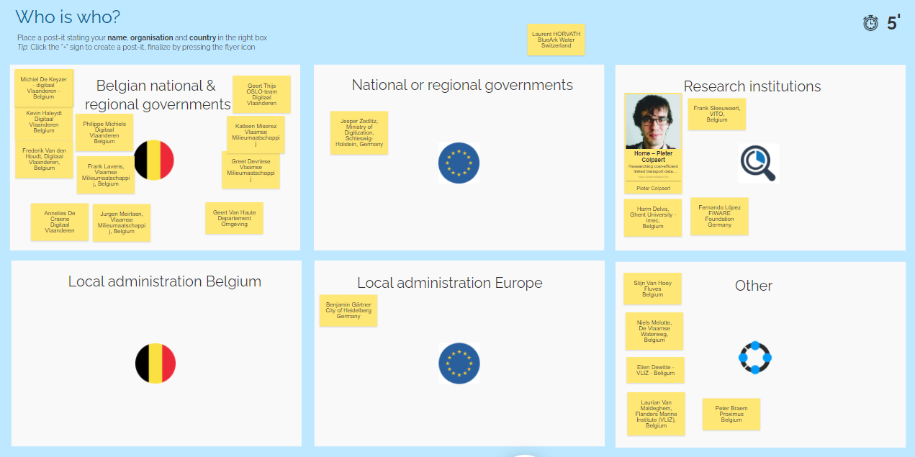

1. **Scope of the OSLO project and results of the previous workshop**

During Part 2, a short introduction was given of the current project, followed by the current scope as well as a recap of what has been discussed in the previous business workshop.

An overview of the envisioned timeline was set out. This timeline can be found below:

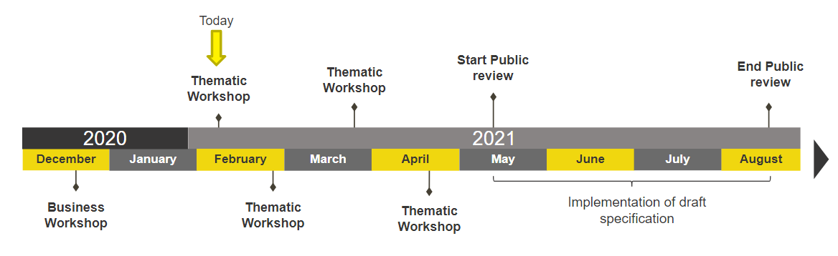

Lastly, the outcomes of the previous business workshop were highlighted, namely:

* What is the scope of the use cases?
* What do we want to measure?
* What data is needed?
  + Sensor related data
  + Metadata on measurements
  + Other examples such as sewer and river network topology, reference to characterise the water quality regarding the context/usage, data about emission points of all substances, pollution origins estimations.

Additional input was provided on the different “categories of information” via Klaxoon. The input can be found below:

|  |  |
| --- | --- |
| **Data about the measurement itself:**   * All elements available in ISO O&M * Chromatogram - Liquid chromatography mass spectrometry * Waterplants * Fauna (e.g. # of blue mussels) * Measure pollutant * Identification of what you measured (which parameter) * Environmental parameters during measurement * Water pollutants * Type of measurement (chemical, physical, biological status) * Associations between observations * Identification of the object you observe (or proxy object = sample or sampling spot…) * Unit of measurement * Kind of aggregation (1-hour avg., 1 hour maximum, daily maximum) * Connected to the water smart meter | **Data about the measurement device:**   * Date since device is active * Health status (up/down/faulty) * Calibration * Reliability of the data * All elements available in SOSA/SSN * Admin status (device active or not) * Sensor calibration parameters * Biological observation method like ‘transect’ * Time of last measurement * Location * Station code * Asset management (when it was installed, , where, for how long,...) * Time of deployment * Fair chip design * Age - brand - type - material * Manufacturer or model of the device |
| **Data about the context of the measurement:**   * Type of installation * Measurement unit * date/time * Location * Identification of the river at which the device is installed * Information about the matrix (air, water, sediment) * Coordinates * Type of emission source (industry, …) * Must be connected to the schematic (a plan for the workers that will use it to repair the device/pipe) * Location in the building * Typical values/treshold values * Waterbody and river reference * Must be connected to an object (pipe) * How the observation was made (sensor, procedure) * Distinctions between fixed stations and measurements along transects * Sampling methodology * Labreport * Method of analysis in the lab | **Administrative metadata:**   * Contact address * Quality assurance steps already performed * License (open, limited, closed) * Shape of the observation object * Date of oldest and newest observation * Owner and maintainer of the device |

1. **Reviewing the preliminary use case**

We proceeded with the workshop by detailing a short use case and using this as a reference to go through the basic building blocks (classes) of an initial draft proposal. The storyline of the use case was:

* A government institution in Madrid would like to monitor the air quality of the city by measuring substances in the air on different locations throughout the city
* To accomplish this, several sensors were placed across the city to capture the required air quality data
* The institution would like to measure data such as CO- and SO2 concentrations.

The main building blocks that were proposed based on existing international standards are represented in the UML diagram below.

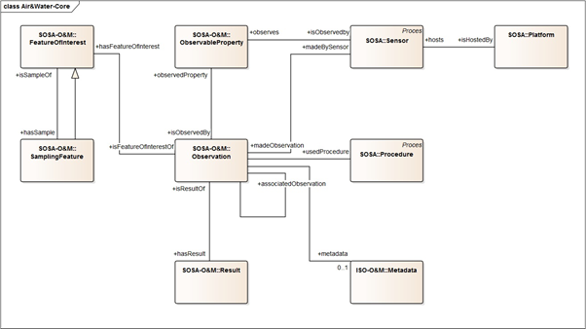

### Discussion points raised concerning the initial draft model:

*Aspects to be clarified by the next workshop:*

* What about measurement or observation of biological indicators such as the presence of microorganisms. To be clarified in the next workshop how or if ObservableProperty can also cover this.
* How can we make sure chromatograms can also fit within the model?
* The model should also be able to document the sampling method or how the analysis was done in the lab.
  + To be analysed if this is something that can be covered by the ‘Procedure’ class.
* How will we determine which observable properties are possible within the model? Several possibilities were brought forward in the workshop, namely:
  + WaterML refers to [QUDT](http://www.qudt.org/) “quantity types” which includes a whole list of parameters that can be observed. May be missing some things like for example PM1.
  + Skos can be leverage to determine the observable properties by means of a codelist
  + W3C Cube allows you for certain properties to be coded property and in the class definition of the property there would be a link where the skos list is
  + Specifically for water, the [P01 (BODC PARAMETER USAGE VOCABULARY)](https://vocab.seadatanet.org/v_bodc_vocab_v2/browse.asp?order=conceptid&formname=search&screen=0&lib=p01&v0_0=&v1_0=conceptid%2Cpreflabel%2Caltlabel%2Cdefinition%2Cmodified&v2_0=0&v0_4=&v1_4=modified&v2_4=9&v0_5=&v1_5=modified&v2_5=10&x=29&y=30&v1_6=&v2_6=&v1_7=&v2_7=) could be leveraged
* Investigation of the provenance of the pollution
  + For example what is the impact of the pollution of a sewer on a specific lake? How will we deal with this in the model
* How can flood predictions be fit in the model?
  + Translate to an observation, for example:
    - Link with water quantity
    - Link with water level
  + WaterML is very detailed on water level observations (and the relation between level and discharge)
    - <https://docs.opengeospatial.org/is/15-018r2/15-018r2.html>

*General points of information:*

* Additional models to take into account:
  + European water framework standard - SOE water quality
    - <http://dd.eionet.europa.eu/datasets/latest/WISE-SoE_WaterQualityICM>
    - <http://dd.eionet.europa.eu/dataelements/75873>
  + w3c cube integration with ssn sosa
  + Water framework directive: “observedPropertyDeterminandCode”
    - <http://dd.eionet.europa.eu/dataelements/75873>

*Additional questions and input from klaxoon:*

* How similar is the draft model for air to water? Which aspects are different and which aspects are similar?
  + Relationships between different entities in a Water Distribution Network
  + Some pollutants are the same, but it will be needed to add specific water pollutants or indicators (microorganisms for example?)
  + Actuations & Sampling
  + When a sensor is connected to an object (for example pipe), how can we identify the same objects (between cities)
  + Upstream/downstream connections in rivers
  + Spatial context is different for water: For example rivers, sewers, lakes and the interconnections.
  + Do we take into account the links with SIG & BIM platforms?
* Do we cover all use cases?
  + Water pollutants: the quality of drinking water
  + Irrigation (soil, humidity, river levels, amount of water consumed)
  + Waste water
  + Water Distribution Networks
  + Missing the direct link (dimension) ‘method’ on the observation
  + (Biological) Quality of swimming waters
  + Measurement of emission point sources of air/water such as for example chimney emissions in industry
  + Air pollution measurements (similar in all of Germany)
  + Water height and flow rate of rivers
  + Where is the provenance of the pollution?
  + To check with the model: a sensor e.g. pH probe has calibration parameters with associated observations . Other measurements use these calibration parameters.
* What information or classes needs to be added or detailed?
  + Measurement unit following UNECE/CEFACT
  + Details on the sampling feature
  + Handmade results (such as chemical analysis results)
  + Satellite data (for water)
  + Aggregation levels: how observations relate to the raw data
  + Taxon list biology
  + The notion whether an observed property is a codedProperty, valueProperty, dimensionProperty.

1. **Initial thoughts of comparison**

In the analysis done prior to the workshop, multiple international standards were analyzed and compared, such as (but not limited to) SOSA, WaterML, INSPIRE Atmospheric Conditions, ISO Observations & Measurements. Our main findings were that:

* Most existing standards are building further on ISO Observations & Measurements. Hence we chose to also base the initial proposal on the ‘Observation’ schema used in ISO O&M.
* Other standards mainly provide additional building blocks such as:
  + Sensor data (SOSA)
  + Timeseries (WaterML)
  + Quantity Types via QUDT (WaterML)
* Furthermore, ISO O&M itself elaborates on other existing standards such as OGC Spatial Coverage, ISO metadata, ...

1. **The object diagram**

Following the use case listed above, an object diagram was also presented which provided a more practical illustration of the initial draft model. The model can be consulted below:

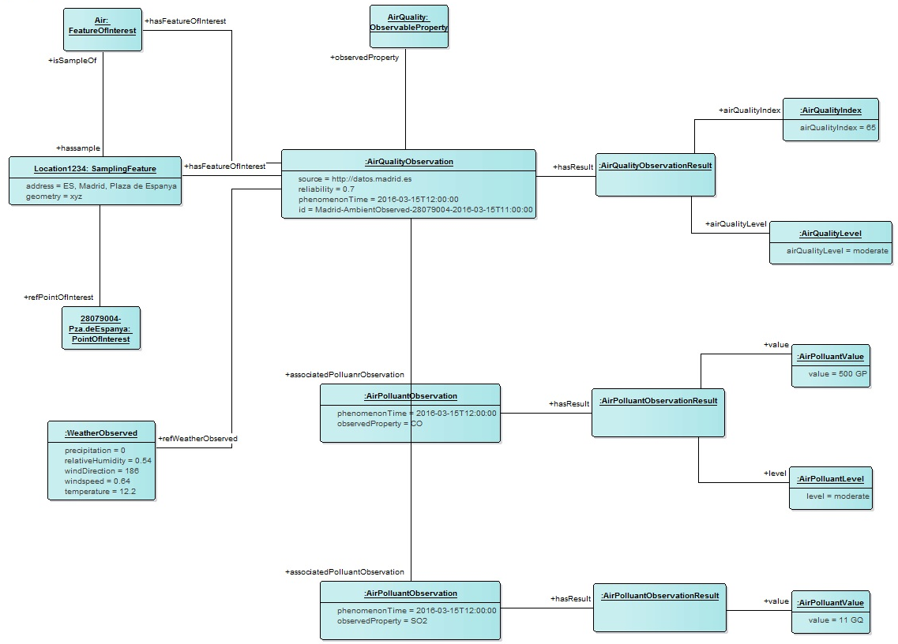

1. **Next steps**

* The next workshop is planned on March 4th, 2021 from 13h to 15h30. Don’t forget to subscribe if you haven’t already via the following [**LINK**](https://overheid.vlaanderen.be/informatie-vlaanderen/agenda/thematic-workshop-2-oslo-air-water).
* Participants of the workshop can review draft model and submit their additional feedback or questions via email or Github
  + You can send your questions to either Kevin Haleydt or Frederik Van Den Houdt
    - [kevin.haleydt@vlaanderen.be](mailto:kevin.haleydt@vlaanderen.be)
    - [frederik.van.den.houdt@pwc.com](mailto:frederik.van.den.houdt@pwc.com)
  + Or you can submit your feedback and questions via Github:
    - You can access the dedicated Github page via [**https://github.com/Informatievlaanderen/OSLOthema-airAndWater**](https://github.com/Informatievlaanderen/OSLOthema-airAndWater)
    - To submit your feedback or questions on the Github, you’ll need to navigate to the ‘issues’ tab and click on the green button named ‘new issue’

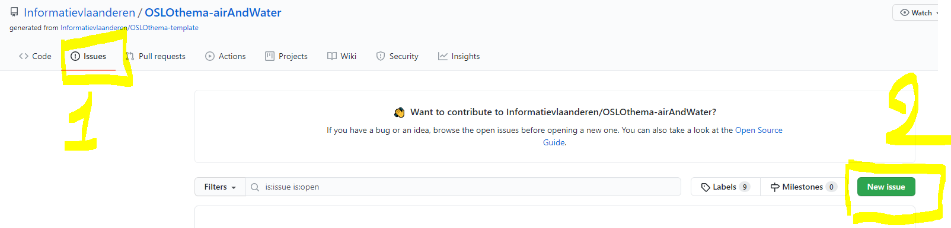

* A **finetuning will be done of the model based on the feedback** captured during this workshop or sent to us via email or Github. Feedback that was received in the workshop & which we will investigate further are amongst others:
  + Observable Property
    - Flexibility of this class, can it for example include microorganisms etc…
    - Investigate other standards to see which type of lists already exist (QUDT & other code lists)
    - Can the procedure class be applicable to sampling or lab analysis as well
    - Provenance of pollution
    - Flood prediction
* The model will be further extended with new information and we will prepare an in-depth discussion on the **attributes** that will be needed in the model.
* **Definitions will be prepared for the core concepts of the model**